Two of my favorite source code control commands are git cherry-pick and git revert. The git cherry-pick command is great when you need to pull in a bug fix from another active branch. And the ability to git revert a commit is great way to back out of a bad contribution to the code base. But as useful as these commands are, I rarely see them being used on active projects. Team leads often go to exorbitant lengths to undo a problem in their source code repository when they could just git revert a commit instead. The goal of this tutorial is to provide a simple git revert example that demonstrates how the command works, and how it can be used to revert a specific commit.

A git revert example

In the name of simplicity, this git revert example will start off with a completely clean repository. That means issuing a quick git init command.

/c/ git revert changes example
$ git init
Initialized empty Git repository in C:/ git revert changes example/.git/

With the git repository initialized, five html files will be created, with a git commit issued each time a file is created. To keep track of the commit history, each commit will include the commit number along with the count of the number of files in the working tree. We will then git revert a previous commit and examine the state in which it leaves our development environments.

/c/ git revert changes example
$ echo 'alice' > alpha.html
$ git add . && git commit -m "1st git commit: 1 file"

$ echo 'becky' > beta.html
$ git add . && git commit -m "2nd git commit: 2 files"

$ echo 'callie' > charlie.html
$ git add . && git commit -m "3rd git commit: 3 files"

$ echo 'diana' > delta.html
$ git add . && git commit -m "4th git commit: 4 files"

$ echo 'ellen' > edison.html
$ git add . && git commit -m "5th git commit: 5 files"

To recap this git revert example, we have created five html files, and after each file was created we executed a commit. The history can be viewed by invoking the git reflog command:

/c/ git revert changes example
$ git reflog
(HEAD -> master)
d846aa8 HEAD@{0}: commit: 5th git commit: 5 files
0c59891 HEAD@{1}: commit: 4th git commit: 4 files
4945db2 HEAD@{2}: commit: 3rd git commit: 3 files
defc4eb HEAD@{3}: commit: 2nd git commit: 2 files
2938ee3 HEAD@{4}: commit: 1st git commit: 1 file

What happens when we git revert a commit?

At this point we have five files in the working directory. What would happen if we were to git revert a commit. If we performed a git revert on the third git commit, the one where we added the file named charlie.html, in what type of state would git leave our development environment? When developers git revert a commit for the first time, they usually have one of three guesses about what executing the command will do:

1. The git revert will leave 2 files on the filesystem, alpha.html and beta.html, rolling us back the the state prior to the third commit.
2. The git revert will leave 3 files on the filesystem, alpha.html, beta.html and charlie.html, taking us back to the state at which the third commit occured
3. The git revert will leave us with four files, removing only charlie.html, the only file associated exclusively with the third commit.

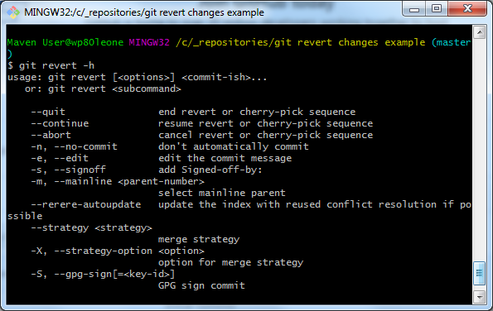

Figure 1. The command used to git revert a commit
The correct answer can be surmised by issuing the git revert on the third commit.

/c/ git revert changes example
$ git revert 4945db2

After performing the revert, a simple directory listing shows us that four files remain, with the file named charlie.html removed.

/c/ git revert changes example
$ ls
alpha.html beta.html delta.html edison.html

As you can see from this git revert example, when you git revert a previous commit, the only the changes associated with that previous commit get removed. Changes prior to that previous commit remain, and changes made after that previous commit remain. When you git revert a previous commit, the only thing plucked out of your development environment are the changes explicitly associated with the reverted commit. In this case, the third commit added the file charlie.html to the source code repository. When that third commit fell victim to the git revert command, the file named charlie.html was removed from the working tree.

And that's it. That's what happens when you git revert a commit. It's a great way to remove a bug that may have been introduced into the VCS at some point in the past, or back out of a feature enhancement that wasn't well received by the client. It's definitely a feature of Git that can save the DevOps team a lot of time when they need to roll back small, historic change without wiping out all of the good changes and updates that have subsequently been committed.

